# **Index**

|  |  |  |  |
| --- | --- | --- | --- |
| **Sr. No.** | **Topic** | **Page No.** | **Sign** |
| 1. | Abstract | 1 |  |
| 2. | Problem statement | 2 |  |
| 3. | Methodology | 3 |  |
| 4. | Working | 4 |  |
| 5. | Components Used | 6 |  |
| 6. | Flow chart | 8 |  |
| 7. | Circuit Diagram | 9 |  |
| 8. | Advantages over existing methods | 12 |  |
| 9. | Feasibility | 14 |  |
| 10. | Future Improvements | 16 |  |
| 11. | Timeline | 17 |  |
| 12. | Conclusion | 18 |  |
| 13. | References | 19 |  |

0

# **Abstract**

IoT-based smart energy control system specifically developed to optimize air conditioning usage in rooms, contributing to energy conservation and supporting green technology initiatives. By integrating embedded systems with a cloud-based real-time database, the system dynamically monitors room occupancy and both indoor and outdoor temperatures to manage air conditioning operations effectively.

The system features a dual-sensor mechanism to accurately track room occupancy, distinguishing entry and exit movements, and synchronizes this data with a cloud database. User-configurable parameters, such as maximum occupancy and temperature thresholds, are also stored in the database. Based on real-time data inputs, the system calculates the optimal air conditioning temperature using a custom algorithm that considers room occupancy, indoor temperature, and outdoor temperature. If no occupants are present, the air conditioning is turned off, transitioning the system to an inactive state to conserve energy. When occupants are detected, the system dynamically adjusts the air conditioning settings to maintain comfort while minimizing energy usage.

A web-based dashboard offers real-time visualization of critical parameters, including occupancy count, indoor and outdoor temperatures, and air conditioning status. Administrators can remotely configure settings, enhancing user control and operational flexibility.

The uniqueness of this system lies in its ability to seamlessly integrate occupancy tracking with temperature monitoring and provide real-time, automated control. Unlike conventional control systems that rely solely on temperature or manual adjustments, this system combines multiple data points to deliver a holistic and energy-efficient solution. Designed for room-level implementation, it is scalable to larger spaces or facilities, making it adaptable for future needs.

As a part of green technology, this project demonstrates a sustainable approach to energy management, reducing unnecessary power consumption and contributing to environmental conservation efforts.

# **Problem Statement**

In today’s rapidly evolving world, energy consumption continues to be a major concern, particularly in residential, commercial, and office buildings where air conditioning (ACS) systems account for a significant portion of energy use. As global temperatures rise and the demand for comfort increases, traditional ACS systems often operate inefficiently, leading to excessive energy consumption, higher operational costs, and an increased environmental footprint. These systems typically rely on fixed schedules or manual adjustments, which fail to respond to real-time factors like room occupancy, individual preferences, or fluctuating weather conditions. As a result, air conditioning units continue to run even when spaces are unoccupied or when the temperature is already within a comfortable range, wasting valuable energy.

This inefficiency is further compounded by the lack of real-time data-driven control, which prevents users from optimizing their energy consumption. In many cases, users are unable to monitor energy usage effectively or make adjustments in a way that balances comfort and cost savings. This leads to unnecessary cooling or heating, particularly in spaces that are temporarily unoccupied, which not only wastes energy but also increases electricity bills and exacerbates the strain on energy grids.

Furthermore, with growing awareness of climate change and the need for sustainability, there is a critical demand for solutions that can reduce energy waste, decrease carbon footprints, and align with green technology initiatives. While smart home and building automation technologies are becoming more prevalent, many systems still lack the ability to integrate multiple dynamic data sources (such as occupancy, temperature, and outdoor conditions) to optimize air conditioning systems in a way that is both energy-efficient and responsive to users' comfort needs.

**Methodology**

System Design and Architecture

* Hardware Components
* The system uses an ESP32 Microcontroller board as the central processing unit.
* A dual ultrasonic sensor at the entrance/exit of the room for accurate occupancy detection, ensuring they distinguish entry and exit movements.
* A pair of DHT22 Temperature and Humidity Sensors for monitoring both indoor and outdoor temperature and humidity.
* Connects the 16x2 LCD with I2C interface to the ESP32 for displaying real-time data
* Integrates the buzzer and LEDs for alerts
* Using the IR transmitter to send commands to the air conditioning unit
* Programmed this using Arduino IDE to interface with all components.
* Cloud Integration
* The ESP32’s built-in Wi-Fi connects to a cloud database (e.g., Firebase) to synchronize real-time data such as occupancy, temperature, and user settings.

System Communication and Cloud Synchronization

Store real-time data (occupancy, temperature) and retrieve user-defined settings such as preferred temperature ranges and maximum occupancy limits.

Real-Time Monitoring and Control

Developed an API using frameworks like React.js to display real-time parameters, including room occupancy, indoor/outdoor temperatures, and air conditioning status.

System Testing and Validation

* Verify the dual-sensor mechanism effectively differentiates entry and exit movements.
* Ensure the air conditioning operates optimally without manual intervention.
* Collected feedback and made necessary adjustments to the hardware or software.

Deployment and Scalability

* Deploy the system in a room-level environment and monitor its performance over time.
* Plan for scalability to larger spaces or multi-room facilities by adding more sensors and integrating their data into a centralized cloud platform.

**Working**

The IoT-based smart energy control system efficiently regulates air conditioning (AC) by monitoring room occupancy and environmental conditions. By integrating sensors, cloud-based data processing, and real-time control, the system minimizes energy consumption while maintaining user comfort.

Operational Workflow.

1. System Initialization and WiFi Connection :

* When the system is powered on, the ESP32 microcontroller initializes and attempts to connect to WiFi. This connection is essential for uploading sensor data and retrieving user-configured settings (such as temperature thresholds and occupancy limits) from the cloud database.
* An LED indicator shows the WiFi connection status:
* Steady LED – WiFi successfully connected.
* Blinking LED – WiFi connection in progress or disconnected.
* Without WiFi, the system cannot fetch settings or upload data, but local sensor operations and AC control will still function.

1. Occupancy Detection :
   * Two ultrasonic sensors are installed at the room entrance to track entry and exit movements.
   * When a person enters, the sensor increments the occupancy count, and when someone exits, the count decrements.
   * This dual-sensor setup prevents miscounts by accurately distinguishing between entry and exit, ensuring reliable occupancy data.
2. Temperature and Humidity Monitoring :
   * The system uses two DHT22 sensors to measure indoor and outdoor temperature and humidity. This data helps determine the most energy-efficient AC settings.
   * One DHT22 is placed indoors, while the second monitors outdoor conditions to allow for comparative analysis.
3. Real-Time AC Control Based on Occupancy and Temperature :
   * If the room is occupied, the ESP32 calculates the optimal AC temperature using occupancy data and indoor/outdoor temperature readings.
   * The AC operates in an active state when occupants are detected.
   * When the room becomes unoccupied, the system switches to an inactive state by turning off the AC, preventing unnecessary energy consumption.
4. Cloud Data Management and Remote Configuration :

* While the system operates, sensor data (occupancy count, temperature, and AC status) is continuously uploaded to a cloud-based database.
* Administrators can remotely monitor and adjust system parameters, such as maximum room occupancy or temperature settings, through a web-based dashboard.

1. WiFi Disconnection Handling :
   * If WiFi disconnects during operation, the system continues functioning locally, maintaining occupancy tracking and AC control. However, data uploads to the cloud and remote monitoring are paused.
   * When WiFi reconnects, the system automatically resumes data uploads without manual intervention.
2. Power Outage and Recovery :
   * In case of a power cut, the system restarts upon power restoration. The ESP32 reconnects to WiFi and retrieves the latest settings from the cloud database.
   * This ensures the system resumes normal operation without requiring reconfiguration or manual input.

System States

* Active State:AC is on and dynamically adjusted based on room occupancy and temperature data.
* Inactive State:AC is turned off when the room is empty, conserving energy.

This streamlined process ensures reliable AC control, optimizing energy usage through automated decision-making while providing remote monitoring capabilities.

**Components utilized**

The system is composed of hardware components that work together to detect room occupancy, measure environmental conditions, and control air conditioning.

Below is a detailed list and description of each component used:

### ESP32 Microcontroller

* Quantity**:** 1 unit
* Function**:** Acts as the central processing unit for the system. It collects data from sensors, processes it, and sends the results to the cloud. The ESP32 is chosen for its dual-core performance, WiFi capability, and low power consumption.

### Ultrasonic Sensors

* Quantity**:** 2 units
* Function**:** Used for detecting movement at the room’s entrance. The ultrasonic sensors detect entry and exit to track occupancy, increasing and decreasing the count accordingly.

### DHT22 Temperature and Humidity Sensors

* Quantity**:** 2 units
* Function**:** Measures temperature and humidity, providing critical data for AC regulation. One sensor monitors indoor conditions, while the other tracks outdoor temperature and humidity.

### 16x2 LCD with I2C Interface

* Quantity**:** 2 units
* Function**:** Displays real-time occupancy, indoor/outdoor temperatures, and system status. The I2C interface simplifies connections and reduces wiring complexity.

### Buzzer

* Quantity**:** 1 unit
* Function**:** Emits an alert sound when the occupancy count exceeds the configured maximum limit or when a system fault occurs.

### LEDs

* Function**:** The LED indicates the WiFi connection status:

Steady Light - WiFi is connected and data is being uploaded.

Blinking Light - WiFi is disconnected or reconnecting.

This allows users to quickly assess the system's connectivity at a glance.

### Jumper Wires

* Function**:** Used to interconnect sensors, the microcontroller, and other electronic components on the PCB.

### Printed Circuit Board (PCB)

* Function**:** Provides a solid platform for mounting and interconnecting components, ensuring system reliability and durability.

### 5V 2A Power Adaptor

* Function**:** Supplies power to the ESP32 and other components, ensuring consistent operation.

### IR Transmitter

* Function**:** Sends signals to control the air conditioning unit remotely, based on the data processed by the ESP32. The IR transmitter mimics the AC’s remote control, automating its operation.

**Flow Chart**

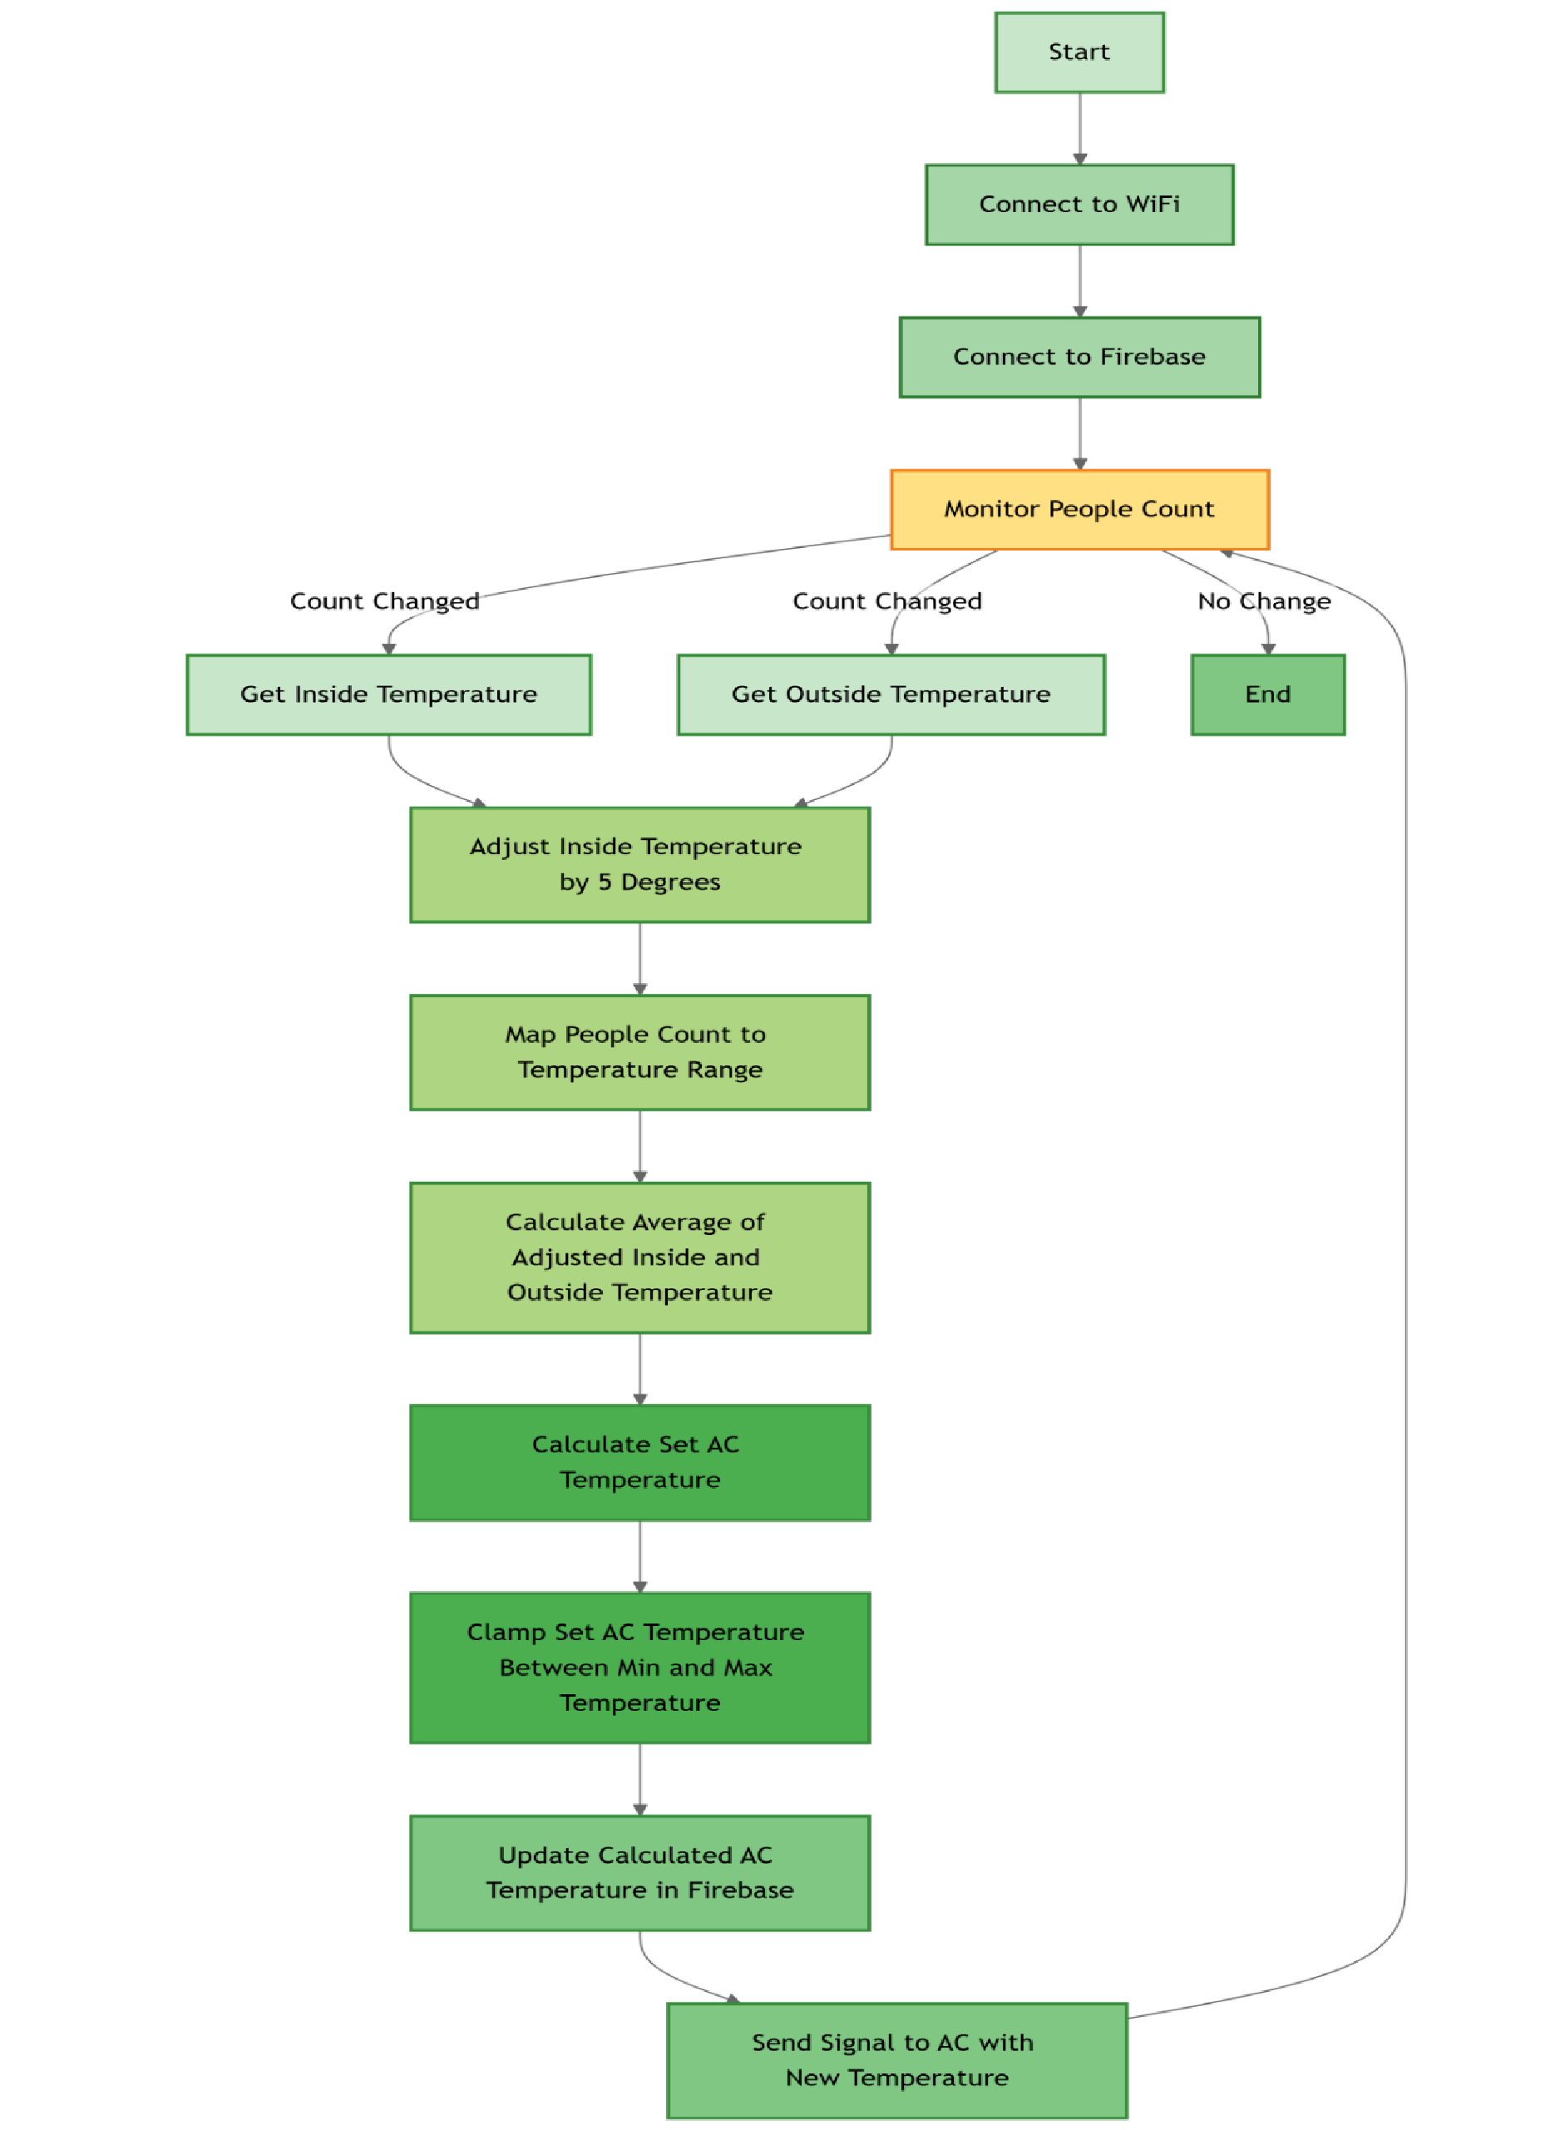

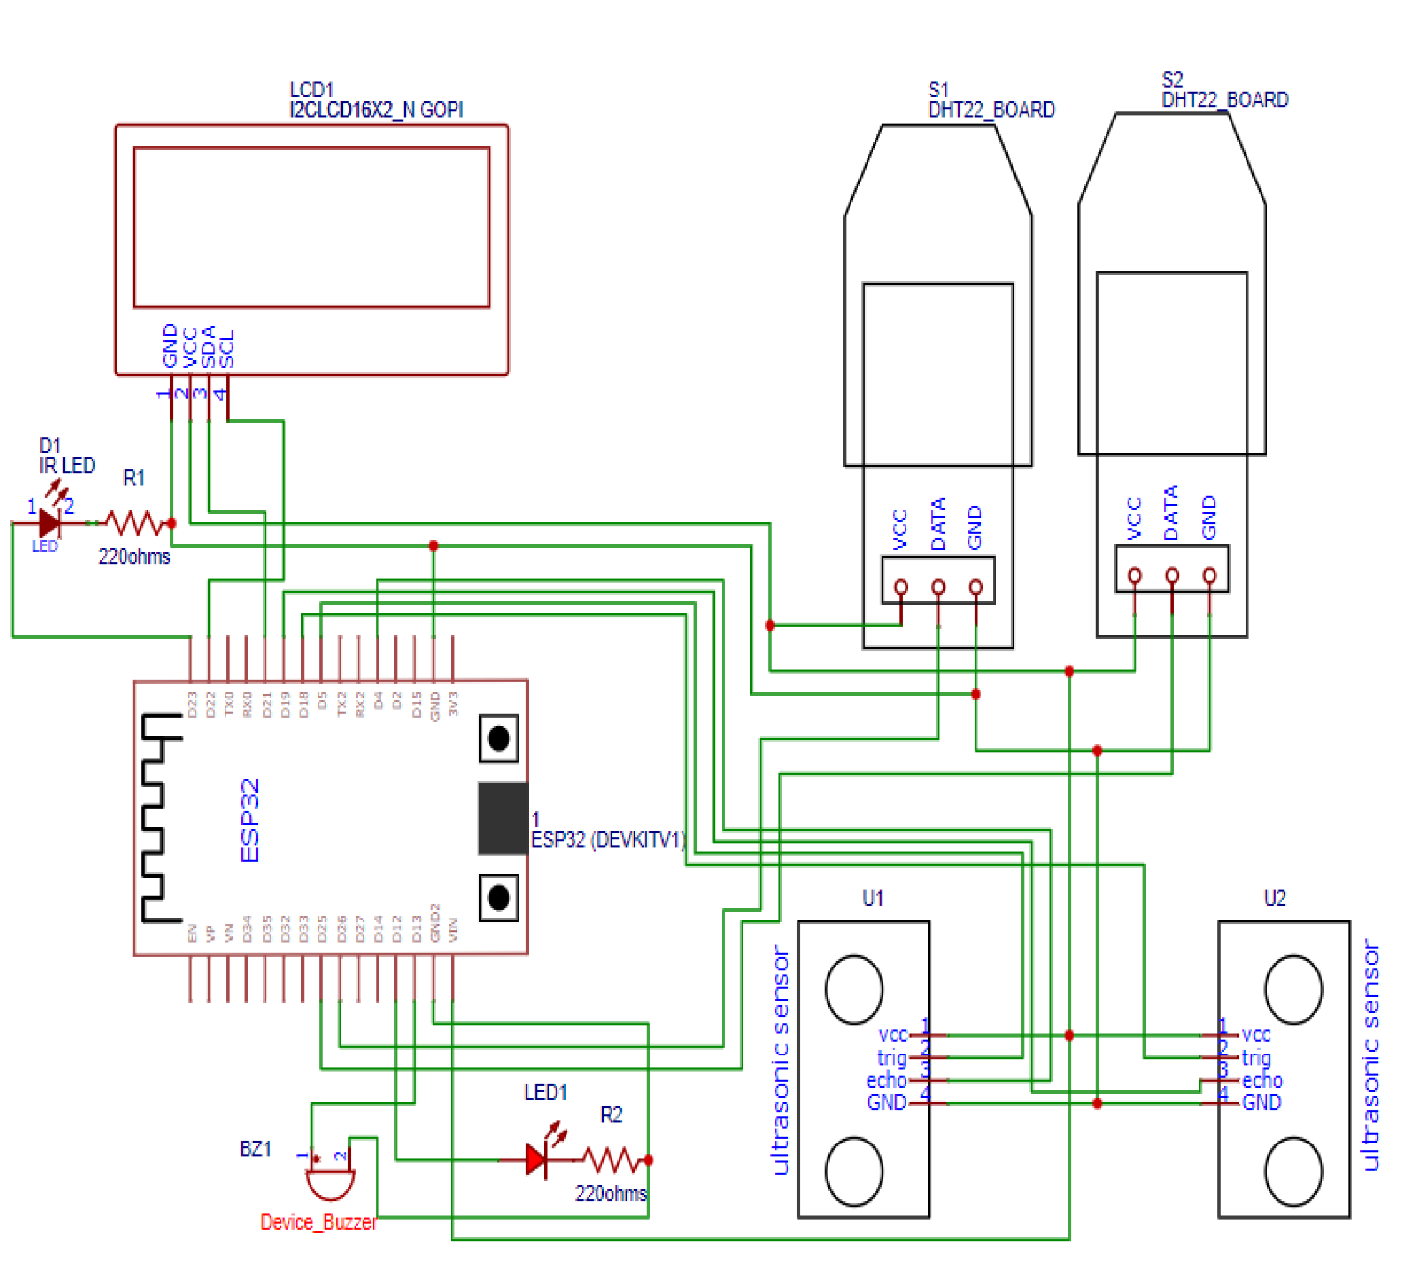**Circuit Diagram.**

**Hardware Images**

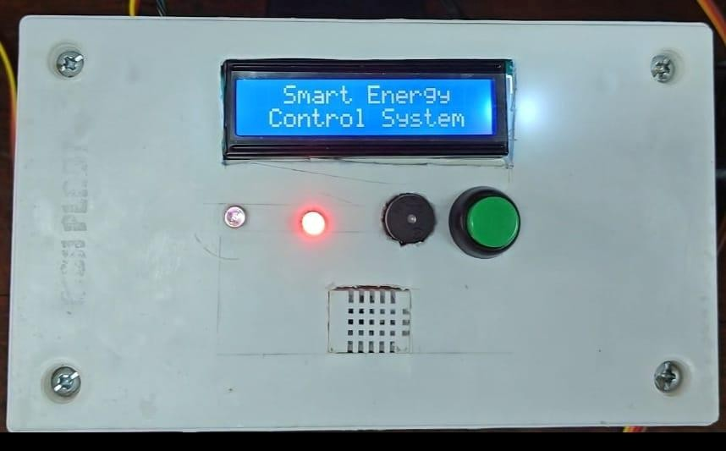

**Software Images**

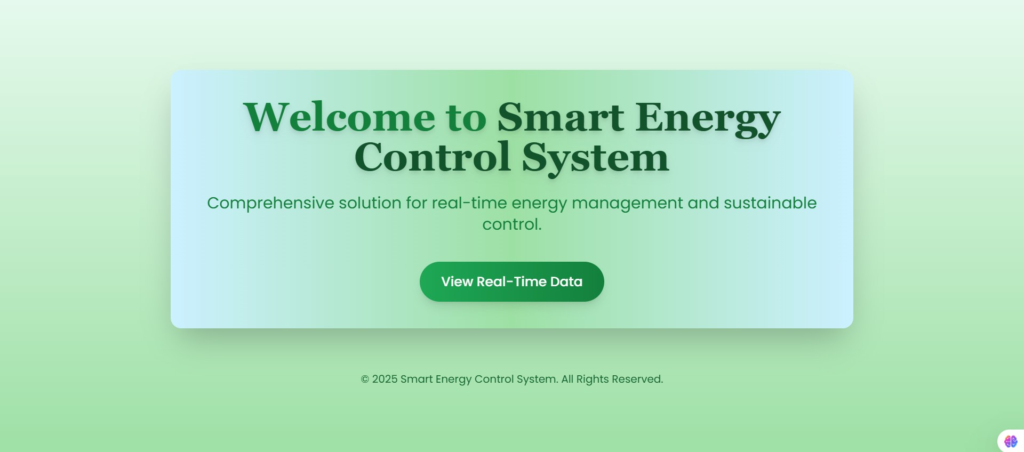

**Dashboard for Monitoring the system**

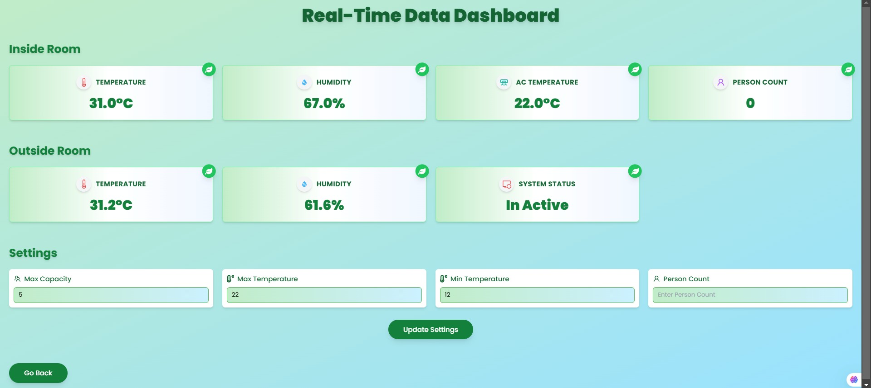

**Advantages over existing methods.**

### 1. Enhanced Energy Efficiency

* Unlike conventional systems that rely on manual AC operation, this system minimizes energy wastage by dynamically controlling the AC based on real-time occupancy and environmental conditions.
* Switching the AC to an inactive state when the room is unoccupied significantly reduces unnecessary power consumption.

### 2. Accurate Occupancy Tracking

* The dual ultrasonic sensor setup prevents miscounts by distinguishing between entry and exit movements, providing more reliable occupancy data than traditional PIR (Passive Infrared) motion sensors, which may only detect movement without considering direction or number of occupants.

### 3. Temperature Optimization

* Integration of indoor and outdoor temperature data ensures optimal AC settings for energy-saving and user comfort. Most existing systems only focus on indoor conditions.

### 4. Remote Monitoring and Control

* Administrators can adjust parameters such as maximum room occupancy, temperature thresholds, and operation modes through a web-based dashboard, enabling flexible and remote system management.
* This feature is often absent in traditional setups or requires separate, costly systems for remote control.

### 5. Local Operation During Connectivity Issues

* Unlike many systems that halt during WiFi disconnection, this system ensures continued operation by maintaining local AC control and occupancy tracking. Data synchronization resumes automatically when WiFi reconnects, offering robustness.

### 6. Automatic Recovery After Power Outages

* The system automatically retrieves the latest settings from the cloud and resumes normal operation without requiring manual intervention after power restoration, enhancing reliability and reducing downtime.

### 7. Improved User Experience

* Real-time feedback via the 16x2 LCD display keeps users informed about room occupancy, temperature, and system status. Conventional systems often lack such visibility for the end-user.

### 8. Cost-Effective Operation

* The use of commonly available and affordable components, such as the ESP32, ultrasonic sensors, and IR transmitter, ensures a cost-effective solution compared to more expensive energy control systems.

### 9. Fault Detection and Alerts

* The system's buzzer alert feature notifies users of occupancy violations (e.g., exceeding room capacity) or system faults, ensuring quick corrective action. This is a feature that many existing systems lack.

### 10.Environmentally Friendly

* By optimizing energy consumption, the system contributes to reducing carbon emissions and promoting sustainable energy use.

#### 11. Scalability and Flexibility

* The modular design of the system allows for easy upgrades or integration with other IoT devices, making it future-proof and scalable for larger or more complex environments.

### 12.User-Centric Design

* Features such as LED indicators for WiFi status and an intuitive interface ensure ease of use for both technical and non-technical users.

**Feasibility**

#### Technical Feasibility

* All components listed (ESP32, ultrasonic sensors, DHT22 sensors, etc.) are readily available in the market and compatible with the proposed system.
* The integration of these components is achievable with standard wiring and PCB design.
* The ESP32 microcontroller supports the required functionalities, including dual-core processing, Wi-fi, and IR transmission.
* The use of sensors for temperature, humidity, and occupancy detection is technically sound and proven in similar applications.
* Cloud integration for data upload and remote control is feasible with existing platforms like Firebase, AWS IoT, or ThingSpeak. Real-time processing of sensor data and AC control through ESP32 is achievable using Arduino IDE or MicroPython. iv. Challenges
* Accurate occupancy detection depends on sensor calibration and proper placement.
* Wifi dependency could be a limitation in areas with unstable internet connections.

#### Economic Feasibility

* The hardware components are cost-effective and suitable for a prototype. ESP32 is an affordable microcontroller with advanced capabilities.
* Additional costs for PCB design and cloud storage/processing are manageable for small-scale projects.
* The system promises significant energy savings by optimizing AC usage, making it a cost-effective solution in the long term.
* Scaling the system for larger spaces may require additional sensors and slight redesigns but remains economically viable.

#### Operational Feasibility

* The system is user-friendly with clear LED indicators and remote monitoring capabilities via a dashboard.
* Automatic adjustments minimize the need for manual intervention.
* The system handles WiFi disconnection gracefully and resumes normal operation after power outages.
* Local functionality ensures uninterrupted performance even without cloud connectivity.
* Maintenance involves occasional sensor recalibration and system updates, which are manageable.

#### Environmental Feasibility

* By regulating AC usage based on occupancy and environmental conditions, the system significantly reduces energy consumption.
* It contributes to environmental sustainability by minimizing carbon emissions associated with excessive energy usage.

#### Prototype to Product Feasibility

* A functional prototype can be developed using off-the-shelf components (ESP32, sensors, relays, etc.).
* The initial prototype will allow testing of system performance, sensor accuracy, and cloud integration.
* Moving from prototype to a finished product requires refining the hardware design (e.g., creating custom PCBs) and developing a user-friendly interface for widespread use.
* Product testing for durability and reliability will be essential to ensure consistent operation in various real-world environments.
* Once the prototype is validated, mass production can be carried out.
* With careful optimization of the design, the system can be manufactured at scale without significantly increasing costs.
* The scalability of both hardware and software ensures that transitioning to a product for widespread use is achievable.

**Future Improvements**

1. Expand to Larger Spaces: The system can be scaled to manage multiple rooms or even entire buildings like offices, hotels, or shopping malls, with centralized control for better efficiency.
2. Smarter Optimizations: By adding AI, the system could learn from past data and user habits to predict occupancy patterns and adjust settings automatically for maximum comfort and energy savings.
3. Use Renewable Energy: Integrating with solar panels or other renewable energy sources could make the system even more eco-friendly and sustainable.
4. Voice and App Control: Adding compatibility with voice assistants like Alexa or Google Assistant and a dedicated mobile app could make controlling the system more intuitive and user-friendly.
5. Detailed Insights: Providing users with reports on energy usage, system performance, and potential cost savings would help them understand and improve their energy efficiency.
6. Better Accuracy: Upgrading the sensors to distinguish between people and objects would ensure more accurate occupancy tracking, avoiding false triggers.
7. Smart Integration: The system could connect with other smart devices like lights, curtains, or security systems for a seamless smart home or office experience.
8. Personalized Comfort: Users could set profiles for preferred temperature and humidity levels based on their daily routines, ensuring the environment always feels just right.
9. Stronger Security: Enhancing data security measures would protect user information and prevent unauthorized changes to settings.
10. Energy Feedback Alerts: Notify users about energy consumption spikes or unusual activity, encouraging conscious usage and potential cost savings.

# **Timeline**

|  |  |  |  |  |  |
| --- | --- | --- | --- | --- | --- |
|  | Task Name | Start Month | Finish  Month | Planned  Duration  (in days) | Signature of the Guide |
| 1 | Analysis | September | September | 15 |  |
| 1.1 | Defining Problem Statement and Gathering Information | September | September | 7 |  |
| 1.2 | Defining WBS of the Project | September | September | 5 |  |
| 1.3 | Creating Proposal | September | September | 3 |  |
| 2 | Design & Planning | October | October | 20 |  |
| 2.1 | Finalizing Components | October | October | 4 |  |
| 2.2 | Software Design and Algorithm Planning | October | October | 10 |  |
| 2.3 | Cloud Integration Design | October | October | 6 |  |
| 3 | Development & Implementation | October | November | 23 |  |
| 3.1 | Set up Development Environment | October | October | 4 |  |
| 3.2 | Develop System Modules | October | October | 5 |  |
| 3.3 | Cloud Integration & API Development | October | November | 5 |  |
| 3.4 | Integrate System Components | November | November | 9 |  |
| 4 | Testing | November | December | 28 |  |
| 4.1 | Perform System Testing | November | November | 9 |  |
| 4.2 | Documenting Issues Found | November | December | 11 |  |
| 4.3 | Correcting/Resolving Issues Found | December | December | 8 |  |
| 5 | Implementation | December | December | 5 |  |
| 5.1 | On-Site/On-Campus Installation | December | December | 3 |  |
| 5.2 | Demonstration | December | December | 2 |  |

# **Conclusion**

The IoT-based Smart Energy Control System successfully demonstrates an intelligent and efficient solution for optimizing energy consumption in air conditioning . By leveraging real-time data from sensors, the system ensures comfort for occupants while minimizing unnecessary energy usage.

Key outcomes.

1. Enhanced Energy Efficiency: The system significantly reduces power wastage by dynamically controlling AC based on occupancy and environmental conditions.
2. Reliable Automation: Dual ultrasonic sensors and temperature-humidity monitoring ensure accurate data collection and automated responses, eliminating the need for manual intervention.

This project demonstrates the practical application of IoT technology in creating smarter, energy-efficient environments for homes, offices, and other spaces. Its scalable design and adaptability make it a promising step toward sustainable and intelligent energy management solutions.

**References.**

1. [IoT-Based](https://drive.google.com/file/d/1ZayENzKvDpBODOXP_IdTHf1kKc-dCl9A/view?usp=drive_link) [Air](https://drive.google.com/file/d/1ZayENzKvDpBODOXP_IdTHf1kKc-dCl9A/view?usp=drive_link) [Conditioning](https://drive.google.com/file/d/1ZayENzKvDpBODOXP_IdTHf1kKc-dCl9A/view?usp=drive_link) [Control](https://drive.google.com/file/d/1ZayENzKvDpBODOXP_IdTHf1kKc-dCl9A/view?usp=drive_link) [System](https://drive.google.com/file/d/1ZayENzKvDpBODOXP_IdTHf1kKc-dCl9A/view?usp=drive_link) [for](https://drive.google.com/file/d/1ZayENzKvDpBODOXP_IdTHf1kKc-dCl9A/view?usp=drive_link) [Energy](https://drive.google.com/file/d/1ZayENzKvDpBODOXP_IdTHf1kKc-dCl9A/view?usp=drive_link) [Saving](https://drive.google.com/file/d/1ZayENzKvDpBODOXP_IdTHf1kKc-dCl9A/view?usp=drive_link) [-](https://drive.google.com/file/d/1ZayENzKvDpBODOXP_IdTHf1kKc-dCl9A/view?usp=drive_link) [International Journal](https://drive.google.com/file/d/1ZayENzKvDpBODOXP_IdTHf1kKc-dCl9A/view?usp=drive_link) [on](https://drive.google.com/file/d/1ZayENzKvDpBODOXP_IdTHf1kKc-dCl9A/view?usp=drive_link) [Advanced](https://drive.google.com/file/d/1ZayENzKvDpBODOXP_IdTHf1kKc-dCl9A/view?usp=drive_link) [Science](https://drive.google.com/file/d/1ZayENzKvDpBODOXP_IdTHf1kKc-dCl9A/view?usp=drive_link) [Engineering](https://drive.google.com/file/d/1ZayENzKvDpBODOXP_IdTHf1kKc-dCl9A/view?usp=drive_link) [Information](https://drive.google.com/file/d/1ZayENzKvDpBODOXP_IdTHf1kKc-dCl9A/view?usp=drive_link) [Technology](https://drive.google.com/file/d/1ZayENzKvDpBODOXP_IdTHf1kKc-dCl9A/view?usp=drive_link) [-](https://drive.google.com/file/d/1ZayENzKvDpBODOXP_IdTHf1kKc-dCl9A/view?usp=drive_link) [Vol.13 (2023)](https://drive.google.com/file/d/1ZayENzKvDpBODOXP_IdTHf1kKc-dCl9A/view?usp=drive_link) [No.](https://drive.google.com/file/d/1ZayENzKvDpBODOXP_IdTHf1kKc-dCl9A/view?usp=drive_link) [1](https://drive.google.com/file/d/1ZayENzKvDpBODOXP_IdTHf1kKc-dCl9A/view?usp=drive_link) [ISSN:](https://drive.google.com/file/d/1ZayENzKvDpBODOXP_IdTHf1kKc-dCl9A/view?usp=drive_link) [2088-5334.](https://drive.google.com/file/d/1ZayENzKvDpBODOXP_IdTHf1kKc-dCl9A/view?usp=drive_link)
2. [Automated](https://drive.google.com/file/d/13g19OUIDETfqjgFUgvnlMKDeLhLY__WN/view?usp=drive_link) [Air](https://drive.google.com/file/d/13g19OUIDETfqjgFUgvnlMKDeLhLY__WN/view?usp=drive_link) [Conditioner](https://drive.google.com/file/d/13g19OUIDETfqjgFUgvnlMKDeLhLY__WN/view?usp=drive_link) [Controller](https://drive.google.com/file/d/13g19OUIDETfqjgFUgvnlMKDeLhLY__WN/view?usp=drive_link) [and](https://drive.google.com/file/d/13g19OUIDETfqjgFUgvnlMKDeLhLY__WN/view?usp=drive_link) [Monitoring](https://drive.google.com/file/d/13g19OUIDETfqjgFUgvnlMKDeLhLY__WN/view?usp=drive_link) [Based](https://drive.google.com/file/d/13g19OUIDETfqjgFUgvnlMKDeLhLY__WN/view?usp=drive_link) [on](https://drive.google.com/file/d/13g19OUIDETfqjgFUgvnlMKDeLhLY__WN/view?usp=drive_link) [Internet](https://drive.google.com/file/d/13g19OUIDETfqjgFUgvnlMKDeLhLY__WN/view?usp=drive_link) [of Things](https://drive.google.com/file/d/13g19OUIDETfqjgFUgvnlMKDeLhLY__WN/view?usp=drive_link) [-](https://drive.google.com/file/d/13g19OUIDETfqjgFUgvnlMKDeLhLY__WN/view?usp=drive_link) [Indonesian](https://drive.google.com/file/d/13g19OUIDETfqjgFUgvnlMKDeLhLY__WN/view?usp=drive_link) [Journal](https://drive.google.com/file/d/13g19OUIDETfqjgFUgvnlMKDeLhLY__WN/view?usp=drive_link) [of](https://drive.google.com/file/d/13g19OUIDETfqjgFUgvnlMKDeLhLY__WN/view?usp=drive_link) [Electronics](https://drive.google.com/file/d/13g19OUIDETfqjgFUgvnlMKDeLhLY__WN/view?usp=drive_link) [and](https://drive.google.com/file/d/13g19OUIDETfqjgFUgvnlMKDeLhLY__WN/view?usp=drive_link) [Instrumentation](https://drive.google.com/file/d/13g19OUIDETfqjgFUgvnlMKDeLhLY__WN/view?usp=drive_link) [Systems (IJEIS)](https://drive.google.com/file/d/13g19OUIDETfqjgFUgvnlMKDeLhLY__WN/view?usp=drive_link) [Vol.11,](https://drive.google.com/file/d/13g19OUIDETfqjgFUgvnlMKDeLhLY__WN/view?usp=drive_link) [No.1,](https://drive.google.com/file/d/13g19OUIDETfqjgFUgvnlMKDeLhLY__WN/view?usp=drive_link) [April](https://drive.google.com/file/d/13g19OUIDETfqjgFUgvnlMKDeLhLY__WN/view?usp=drive_link) [2021,](https://drive.google.com/file/d/13g19OUIDETfqjgFUgvnlMKDeLhLY__WN/view?usp=drive_link) [pp.](https://drive.google.com/file/d/13g19OUIDETfqjgFUgvnlMKDeLhLY__WN/view?usp=drive_link) [83~92](https://drive.google.com/file/d/13g19OUIDETfqjgFUgvnlMKDeLhLY__WN/view?usp=drive_link) [ISSN](https://drive.google.com/file/d/13g19OUIDETfqjgFUgvnlMKDeLhLY__WN/view?usp=drive_link) [(print):](https://drive.google.com/file/d/13g19OUIDETfqjgFUgvnlMKDeLhLY__WN/view?usp=drive_link) [2088-3714,](https://drive.google.com/file/d/13g19OUIDETfqjgFUgvnlMKDeLhLY__WN/view?usp=drive_link) [ISSN](https://drive.google.com/file/d/13g19OUIDETfqjgFUgvnlMKDeLhLY__WN/view?usp=drive_link) [(online): 2460-7681](https://drive.google.com/file/d/13g19OUIDETfqjgFUgvnlMKDeLhLY__WN/view?usp=drive_link) [DOI:](https://drive.google.com/file/d/13g19OUIDETfqjgFUgvnlMKDeLhLY__WN/view?usp=drive_link) [10.22146/ijeis.64563](https://drive.google.com/file/d/13g19OUIDETfqjgFUgvnlMKDeLhLY__WN/view?usp=drive_link) [.](https://drive.google.com/file/d/13g19OUIDETfqjgFUgvnlMKDeLhLY__WN/view?usp=drive_link)
3. [ResearchGate](https://drive.google.com/file/d/1hRgWcqPTAkNK66Cw3T9orqC1sy2KZ3DR/view?usp=drive_link) [Article](https://drive.google.com/file/d/1hRgWcqPTAkNK66Cw3T9orqC1sy2KZ3DR/view?usp=drive_link) [:](https://drive.google.com/file/d/1hRgWcqPTAkNK66Cw3T9orqC1sy2KZ3DR/view?usp=drive_link) [Green](https://drive.google.com/file/d/1hRgWcqPTAkNK66Cw3T9orqC1sy2KZ3DR/view?usp=drive_link) [Air](https://drive.google.com/file/d/1hRgWcqPTAkNK66Cw3T9orqC1sy2KZ3DR/view?usp=drive_link) [Conditioning](https://drive.google.com/file/d/1hRgWcqPTAkNK66Cw3T9orqC1sy2KZ3DR/view?usp=drive_link) [–](https://drive.google.com/file/d/1hRgWcqPTAkNK66Cw3T9orqC1sy2KZ3DR/view?usp=drive_link) [Using](https://drive.google.com/file/d/1hRgWcqPTAkNK66Cw3T9orqC1sy2KZ3DR/view?usp=drive_link) [indoor](https://drive.google.com/file/d/1hRgWcqPTAkNK66Cw3T9orqC1sy2KZ3DR/view?usp=drive_link) [living](https://drive.google.com/file/d/1hRgWcqPTAkNK66Cw3T9orqC1sy2KZ3DR/view?usp=drive_link) [wall systems](https://drive.google.com/file/d/1hRgWcqPTAkNK66Cw3T9orqC1sy2KZ3DR/view?usp=drive_link) [as](https://drive.google.com/file/d/1hRgWcqPTAkNK66Cw3T9orqC1sy2KZ3DR/view?usp=drive_link) [a](https://drive.google.com/file/d/1hRgWcqPTAkNK66Cw3T9orqC1sy2KZ3DR/view?usp=drive_link) [climate](https://drive.google.com/file/d/1hRgWcqPTAkNK66Cw3T9orqC1sy2KZ3DR/view?usp=drive_link) [control](https://drive.google.com/file/d/1hRgWcqPTAkNK66Cw3T9orqC1sy2KZ3DR/view?usp=drive_link) [method.](https://drive.google.com/file/d/1hRgWcqPTAkNK66Cw3T9orqC1sy2KZ3DR/view?usp=drive_link)
4. Erickson, V. L., & Cerpa, A. E. (2010). Occupancy based demand response HVAC control strategy. Proceedings of the 2nd ACM Workshop on Embedded Sensing Systems for Energy-Efficiency in Buildings.
5. Bousquet, J. C., et al. (2020). Sustainable IoT systems for energy management: Applications and strategies. Sustainable Computing: Informatics and Systems, 25, 100456.